Assignment No: 1

**Title of the Assignment:** Linear regression by using Deep Neural network: Implement Boston housing price. Prediction problem by linear regression using Deep Neural network. Use Boston House price prediction dataset.

**Objective of the Assignment:** To perform Linear regression by using Deep Neural network on Boston House Dataset.

**Outcome of the Assignment:** To find the best scenario for the result to be achieved for a given data set using linear regression.

**Prerequisite:**

1. Basic of programming language
2. Concept of Linear Regression
3. Concept of Deep Neural Network

**Theory:** Linear regression is a statistical approach that is commonly used to model the relationship between a dependent variable and one or more independent variables. It assumes a linear relationship between the variables and uses mathematical methods to estimate the coefficients that best fit the data.

Deep neural networks are a type of machine learning algorithm that are modeled after the structure and function of the human brain. They consist of multiple layers of interconnected neurons that process data and learn from it to make predictions or classifications. Linear regression using deep neural networks combines the principles of linear regression with the power of deep learning algorithms. In this approach, the input features are passed through one or more layers of neurons to extract features and then a linear regression model is applied to the output of the last layer to make predictions. The weights and biases of the neural network are adjusted during training to optimize the performance of the model. This approach can be used for a variety of tasks, including predicting numerical values, such as stock prices or housing prices, and classifying data into categories, such as detecting whether an image contains a particular object or not. It is often used in fields such as finance, healthcare, and image recognition.

**Example of Linear Regression:**

A suitable example of linear regression using deep neural network would be predicting the price of a house based on various features such as the size of the house, the number of bedrooms, the location, and the age of the house. In this example, the input features would be fed into a deep neural network, consisting of multiple layers of interconnected neurons. The first few layers of the network would learn to extract features from the input data, such as identifying patterns and correlations between the input features.

The output of the last layer would then be passed through a linear regression model, which would use the learned features to predict the price of the house. During training, the weights and biases of the neural network would be adjusted to minimize the difference between the predicted price and the actual price of the house. This process is known as gradient descent, and it involves iteratively adjusting the model's parameters until the optimal values are reached. Once the model is trained, it can be used to predict the price of a new house based on its features. This approach can be used in the real estate industry to provide accurate and reliable estimates of house prices, which can help both buyers and sellers make informed decisions.

**Concept of Deep Neural Network-** The classification of the Deep Neural Network is illustrated in Figure 1.

Refer Figure 1 for the detailed classification.

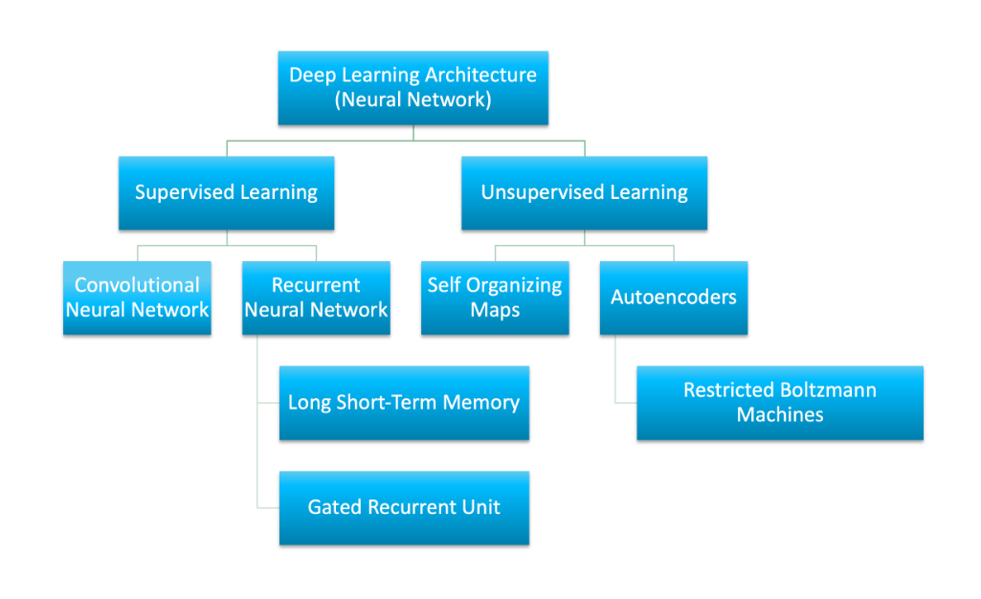

**Figure1:DNN-CLASSIFICATION**

A deep neural network is a type of machine learning algorithm that is modeled after the structure and function of the human brain. It consists of multiple layers of interconnected nodes, or artificial neurons, that process data and learn from it to make predictions or classifications. As shown in figure.

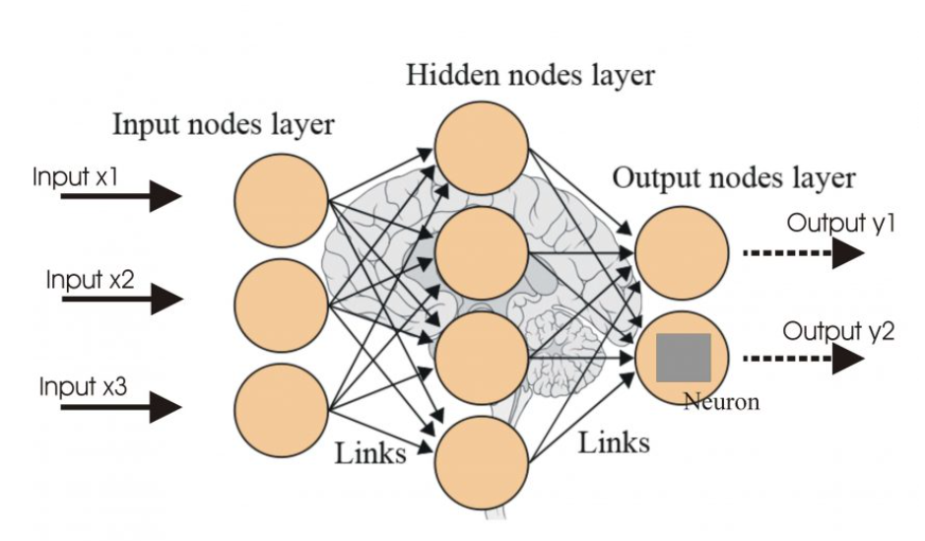

**Figure 2: Deep Learning Architecture**

Each layer of the network performs a specific type of processing on the data, such as identifying patterns or correlations between features, and passes the results to the next layer. The layers closest to the input are known as the "input layer", while the layers closest to the output are known as the "output layer".

The intermediate layers between the input and output layers are known as "hidden layers". These layers are responsible for extracting increasingly complex features from the input data, and can be deep (i.e., containing many hidden layers) or shallow (i.e., containing only a few hidden layers).

Deep neural networks are trained using a process known as backpropagation, which involves adjusting the weights and biases of the nodes based on the error between the predicted output and the actual output. This process is repeated for multiple iterations until the model reaches an optimal level of accuracy.

Deep neural networks are used in a variety of applications, such as image and speech recognition, natural language processing, and recommendation systems. They are capable of learning from vast amounts of data and can automatically extract features from raw data, making them a powerful tool for solving complex problems in a wide range of domains.

**Deep Neural Network Working-**

Boston House Price Prediction is a common example used to illustrate how a deep neural network can work for regression tasks. The goal of this task is to predict the price of a house in Boston based on various features such as the number of rooms, crime rate, and accessibility to public transportation.

Here's how a deep neural network can work for Boston House Price Prediction:

1. **Data preprocessing:** The first step is to preprocess the data. This involves normalizing the input features to have a mean of 0 and a standard deviation of 1, which helps the network learn more efficiently. The dataset is then split into training and testing sets.
2. **Model architecture:** A deep neural network is then defined with multiple layers. The first layer is the input layer, which takes in the normalized features. This is followed by several hidden layers, which can be deep or shallow. The last layer is the output layer, which predicts the house price.
3. **Model training:** The model is then trained using the training set. During training, the weights and biases of the nodes are adjusted based on the error between the predicted output and the actual output. This is done using an optimization algorithm such as stochastic gradient descent.
4. **Model evaluation:** Once the model is trained, it is evaluated using the testing set. The

performance of the model is measured using metrics such as mean squared error or mean absolute error.

1. **Model prediction:** Finally, the trained model can be used to make predictions on new data, such as predicting the price of a new house in Boston based on its features.
2. By using a deep neural network for Boston House Price Prediction, we can obtain accurate predictions based on a large set of input features. This approach is scalable and can be used for other regression tasks as well.

**Dataset Summary:**

**Source Code:**

**Output:**

**Conclusion:** - In this manner, we can predict the Boston House Price using a Deep Neural Network. The

linear regression model is applied to the given dataset, and the best-fit equation is calculated.